Random Dungeon Generation

The first level of the dungeon is always begun with a room; that is, the stairway down leads to a room, so you might go immediately to table V and follow the procedure indicate. Always begin a level in the middle of the sheet of graph paper. Keep a side record of all monsters, treasures, tricks/traps, and whatever — a normal dungeon matrix. Discretion must prevail at all times. For example: if you have decided that a level is to be but one sheet of paper in size, and the die result calls for something which goes beyond an edge, amend the result by rolling until you obtain something which will fit with your predetermined limits.

# I — Passages

## Table I.A — Passage general

|  |  |
| --- | --- |
| D20 | Result |
| 1–2 | Straight passage for 60 ft. Roll again. |
| 3–5 | Door. Passage continues unless the door is straight ahead; roll again in this case. |
| 6–10 | Side Passage(s). All continue for 30 ft. Roll again for all |
| 11–13 | Passage Turns and continue for 30 ft. Roll again. |
| 14–16 | Chamber |
| 17 | Stairs |
| 18 | Dead End. (Any wall close to previously mapped sections have 25% chance of secret door) |
| 19 | Trick/Trap. passage continues for 30 ft. Roll again. |
| 20 | Wandering Monster. Roll again before resolving the monster. |

## Table I.B — Side Passage directions

|  |  |
| --- | --- |
| d20 | Result |
| 1–2 | left 90º |
| 3–4 | right 90º |
| 5 | left 45º ahead |
| 6 | right 45º ahead |
| 7 | left 45º behind |
| 8 | right 45º behind |
| 9 | left curve 45º ahead |
| 10 | right curve 45º ahead |
| 11–13 | Three-way intersection (orthogonal) |
| 14–15 | Three-way intersection (two diagonal) |
| 16–19 | Four-way intersection (orthogonal) |
| 20 | Five-way intersection (one diagonal) |

## Table I.C — Passage Turn direction

Re-roll width of passage.

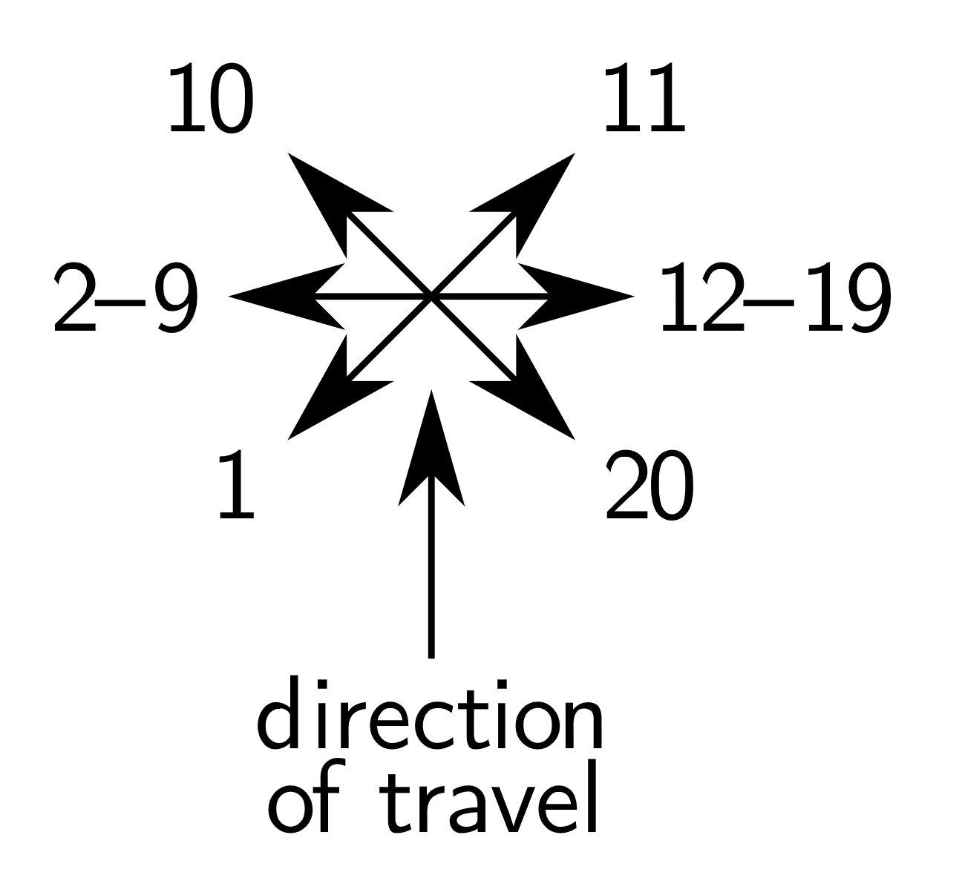

## Table I.D — Passage Width

|  |  |
| --- | --- |
| d20 | Result |
| 1–12 | 10 ft. |
| 13–16 | 20 ft. |
| 17 | 30 ft. |
| 18 | 5 ft. |
| 19–20 | Special Passage (Table III.B) |

## Table I.E — Special Passages

|  |  |
| --- | --- |
| d20 | Result |
| 1–4 | 40’, columns down center |
| 5–7 | 40’, double row of columns |
| 8–10 | 50’, double row of columns |
| 11–12 | 50’, columns 10’ right and left support 10’ wide upper galleries 20’ above. Stairs up to gallery will be at end of passage (1–15) or at beginning (16–20). In the former case if a stairway is indicated in or adjacent to the passage it will replace the end stairs 50% (1–10) of the time and supplement 50% (11–20) of the time. |
| 13–15 | 10’ wide stream bisects the passage. They will be bridged 75% (1–15) of the time and be an obstacle 25% (16–20) of the time. |
| 16–17 | 20’ wide river bisects the passage. They will be bridged 50% (1–10) of the time, have a boat 25% (11–15) of the time (50% chance for either bank) and be an obstacle 25% of the time. |
| 18 | 40’ wide river bisects the passage. They will be bridged 50% (1–10) of the time, have a boat 25% (11–15) of the time (50% chance for either bank) and be an obstacle 25% of the time. |
| 19 | 60’ wide river bisects the passage. They will be bridged 50% (1–10) of the time, have a boat 25% (11–15) of the time (50% chance for either bank) and be an obstacle 25% of the time. |
| 20 | 20’ wide chasm bisects the passage. They are 150’ to 200’ deep. They will be bridged 50% (1–10) of the time, have a jumping place 5’–10’ wide 25% (11–15) of the time, and be an obstacle 25% (16–20) of the time. |

# II — Doors

## Table II.A — Location of door

|  |  |
| --- | --- |
| D20 | Location |
| 1–5 | Left |
| 6–10 | Right |
| 11–18 | Ahead |
| 19–20 | Left and right |

## Table II.B — Space Beyond a Door

This table is for use with doors that exit a room. For passages, consult Table 7: Exit Direction, Chamber Passage. Always check width of corridors on REF.

|  |  |
| --- | --- |
| D20 | Space Beyond Door |
| 1–4 | Parallel passage extends 30’ in both directions. Or 10’ × 10’ room if door is straight ahead |
| 5–8 | Passage straight ahead |
| 9 | Passage 45º ahead/behind (appropriate to circumstances but preference to the first) |
| 10 | Passage 45º behind/ahead (appropriate to circumstances but preference to the first) |
| 11–18 | Room (go to table V) |
| 19–20 | Chamber (go to table V) |

* Check again immediately on table I unless door is straight ahead; if another door is not indicated, then ignore the result and check again 30’ past the door. If a room or chamber is beyond a door, go to table V

# III — Rooms and Chambers

Roll for Shape, Size, and Exits; then Contents, Treasure, and how the latter is contained, if applicable.

## Table III.A — Room

|  |  |  |
| --- | --- | --- |
| d20 | Shape | Calculated Area |
| 1–2 | 10’ × 10’ | 100 |
| 3–4 | 20’ × 20’ | 400 |
| 5–6 | 30’ × 30’ | 900 |
| 7–8 | 40’ × 40’ | 1.600 |
| 9–10 | 10’ × 20’ | 200 |
| 11–13 | 20’ × 30’ | 600 |
| 14–15 | 20’ × 40’ | 800 |
| 16–17 | 30’ × 40’ | 1.200 |
| 18–20 | Unusual shape and size | Varies |

## Table III.B — Chamber

|  |  |  |
| --- | --- | --- |
| d20 | Shape | Calculated Area |
| 1–2 | 20’ × 20’ | 400 |
| 3–4 | 20’ × 20’ | 400 |
| 5–6 | 30’ × 30’ | 900 |
| 7–8 | 40’ × 40’ | 1.600 |
| 9–10 | 20’ × 30’ | 600 |
| 11–13 | 20’ × 30’ | 600 |
| 14–15 | 30’ × 50’ | 1.500 |
| 16–17 | 40’ × 60’ | 2.400 |
| 18–20 | Unusual shape and size | Varies |

## Table III.C — Unusual Room or Chamber

Roll for shape and size individually

|  |  |  |
| --- | --- | --- |
| d20 | Shape | Size (sq. ft.) |
| 1–3 | Triangular | ~ 500 |
| 4–6 | Trapezoidal | ~ 900 |
| 7–8 | Odd-sized | ~ 1,300 |
| 9–10 | Oval | ~ 2,000 |
| 11–12 | Hexagonal | ~ 2,700 |
| 13–14 | Octagonal | ~ 3,400 |
| 15–20 | Circular* | Another roll + 2,000 |

* Has 1 in 6 chance of being a cave instead and may contain a water source. Roll 1d20: 1–5 a pool, 6–7 a well, 8–10 a shaft (See table VIII.A–C)

## Table III.D — Number of Exits

|  |  |  |  |
| --- | --- | --- | --- |
| Die | Below | Area (sq. ft.) | Above |
| 1–3 | 1 | 600 | 2 |
| 4–6 | 2 | 600 | 3 |
| 7–9 | 3 | 600 | 4 |
| 10–12 | 0* | 1.200 | 1 |
| 13–15 | 0* | 1.600 | 1 |
| 16–18 | 1d4 | | |
| 19–20 | 1 — door in chamber, passage in room | | |

* Any section of wall close to another mapped room or passage has a 25% chance of a secret door, otherwise this room/chamber is a dead end.

## Table III.E — Exit Location in Room/Chamber

|  |  |
| --- | --- |
| d20* | Location |
| 1–7 | opposite wall |
| 8–12 | left wall |
| 13–17 | right wall |
| 18–20 | same wall |

* If a passage or door is indicated in a wall where the space immediately beyond the wall has already been mapped, then the exit is either a secret door (1–5) or a one-way door (6–10) or it is located in the opposite wall instead (11–20).

## Table III.F — Chamber Passage Exit Direction

Passage always proceeds in this direction for 30 ft. then roll on table I.A

|  |  |
| --- | --- |
| d20 | Direction (if a Door use table II instead) — check for width on table III.A. |
| 1–16 | straight ahead |
| 17–18 | 45º left/right* |
| 19–20 | 45º right/left* |

* The exit will be appropriate to existing circumstances but use the direction before the slash in preference to the other.

## Table III.G — Chamber or Room Contents

|  |  |
| --- | --- |
| d20 | Result |
| 1–12 | Empty |
| 13–14 | Monster only (determine on appropriate table from APPENDIX C: RANDOM MONSTER ENCOUNTERS, Dungeon Encounter Matrix). |
| 15–17 | Monster and treasure (see table IX below) |
| 18 | Special* or contains stairway up 1 level (1–5), up 2 levels (7–8), down 1 level (9–14), down 2 levels (15–19), or down 3 levels — 2 ﬂights of stairs and a slanting passageway (20). |
| 19 | Trick/Trap (see table VII) |
| 20 | Treasure (see table IX) |

* Determine by balance of level or put in what you desire; otherwise put in stairs as indicated.

STRV: insert a sealed envelope indicating room contents which can be prepared for you by any willing person and open the envelope when indicated above.

# Table IV — Stairs

|  |  |
| --- | --- |
| d20 | Result (roll on table I upon ascending/descending). |
| 1–5 | Down 1 level* |
| 6 | Down 2 levels** |
| 7 | Down 3 levels*** |
| 8 | Up 1 level |
| 9 | Up dead end (1 in 6 chance to chute down 2 levels) |
| 10 | Down dead end (1 in 6 chance to chute down 1 level) |
| 11 | Chimney up 1 level, passage continues, check again in 30’ |
| 12 | Chimney up 2 levels, passage continues, check again in 30’ |
| 13 | Chimney down 2 levels, passage continues, check again in 30’ |
| 14–16 | Trap door down 1 level, passage continues, check again in 30’ |
| 17 | Trap door down 2 levels, passage continues, check again in 30’ |
| 18–20 | Up 1 then down 2 (total down 1), chamber at end (roll on table V) |

* 1 in 20 has a door which closes egress for the day.

** 2 in 20 has a door which closes egress for the day.

*** 3 in 20 has a door which closes egress for the day.

# Table V — Trick/Trap

|  |  |
| --- | --- |
| d20 | Result |
| 1–5 | Secret Door unless unlocated: Non-elf locates 3 in 20, elf locates 5 in 20, magical device locates 18 in 20 (then see table II). Unlocated secret doors go to die 6, 7 below. |
| 6–7 | Pit, 10’ deep, 3 in 6 to fall in. |
| 8 | Pit, 10’ deep with spikes, 3 in 6 to fall in. |
| 9 | 20’ × 20’ elevator room (party has entered door directly ahead and is in room), descends 1 level and will not ascend for 30 turns. |
| 10 | As 9. above, but room descends 2 levels. |
| 11 | As 9. above, but room descends 2–5 levels — 1 upon entering and 1 additional level each time an unsuccessful attempt at door opening is made, or until it descends as far as it can. This will not ascend for 60 turns. |
| 12 | Wall 10’ behind slides across passage blocking it for from 40–60 turns. |
| 13 | Oil (equal to one ﬂask) pours on random person from hole in ceiling, followed by ﬂaming cinder (2d6 HP damage unless successful save vs. magic is made, which indicates only 1–3 HP damage). |
| 14 | Pit, 10’ deep, 3 in 6 to fall in, pit walls move together to crush victim(s) in 2–5 rounds. |
| 15 | Arrow trap, 1d3 arrows, 1 in 20 is poisoned. |
| 16 | Spear trap, 1d3 spears, 1 in 20 is poisoned. |
| 17 | Gas; party has detected it, but must breathe it to continue along corridor, as it covers 60’ ahead. Mark map accordingly regardless of turning back or not. (See table VII. A.) |
| 18 | Door falls outward causing 1d10 HP, or stone falls from ceiling causing 2d10 HP of damage to each person failing his saving throw versus petriﬁcation. |
| 19 | Illusionary wall concealing 8. (pit) above (1–6), 20. (chute) below (7–10) or chamber with monster and treasure (11–20) (see table V). |
| 20 | Chute down 1 level (cannot be ascended in any manner). |

## Table V.A — Gas Sub-Table

|  |  |
| --- | --- |
| d20 | Result |
| 1–7 | Only effect is to obscure vision when passing through. |
| 8–9 | Blinds for 1d6 turns after passing through. |
| 10–12 | Fear: run back 120’ feet unless saving throw versus magic is made. |
| 13 | Sleep: party sound asleep for 2d6 turns (as sleep spell). |
| 14–18 | Strength: adds 1d6 points of strength (as strength spell) to all ﬁghters in party for 1 to 10 hours. |
| 19 | Sickness: return to surface immediately. |
| 20 | Poison: killed unless saving throw versus poison is made. |

# Table VII — Caves and Caverns

You may wish to have “roughhewn” and natural tunnels in lower levels, and where rooms and chambers are indicated substitute Caves and Caverns. Exits are as above.

|  |  |
| --- | --- |
| d20 | Result |
| 1–5 | Cave about 40’ × 60’ |
| 6–7 | Cave about 50’ × 75’ |
| 8–9 | Double Cave: 20’ × 30’, 60’ × 60’ |
| 10–11 | Double Cave: 35’ × 50’, 80’ × 90’* |
| 12–14 | Cavern about 95’ × 125’* |
| 15–16 | Cavern about 120’ × 150’ |
| 17–18 | Cavern about 150’ × 200’* |
| 19–20 | Mammoth cavern about 250’-300’ × 350’-400’** |

* Roll to see if pool therein (see table VIII.A)

** Roll to see if lake therein (see table VIII.B)

## Table VII.A — Pools

|  |  |
| --- | --- |
| d20 | Result |
| 1–8 | No pool |
| 9–10 | Pool |
| 11–12 | Pool and monster |
| 13–18 | Pool, monster and treasure |
| 19–20 | Magical pool* |

* See table VIII.C.

## Table VII.B — Lakes

|  |  |
| --- | --- |
| d20 | Result |
| 1–10 | No lake |
| 11–15 | Lake, no monsters |
| 16–18 | Lake, monsters* |
| 19–20 | Enchanted lake** |

* Determine monster and treasure from appropriate encounter matrix.

** Enchanted lake leads any who manage to cross it to another dimension, special temple, etc. (if special map is available, otherwise treat as lake with monsters), 90% chance that monster will guard lake.

STRV: * 1–4 monsters, 4 in 5 chance of treasure

STRV: ** enchanted lake leads any who manage to cross it to another dimension (if special map is available, otherwise treat as lake with monsters) -- lake will have from 2–5 monsters

## Table VII.C — Magic Pools

In order to find out what a magic pool does, characters must enter it.

|  |  |
| --- | --- |
| d20 | Result |
| 1–8 | Turns gold to platinum (1–11) or lead (12–20), one time only. |
| 9–15 | Will, on a one-time only basis, add (1–3) or subtract (4–6) from one ability score rolled randomly of all who stand within it. (add or subtract from 1–3 points, checking for each character as to addition or subtraction, characteristic, and amount). |
| 16–17 | Talking pool which will grant 1 wish to characters of its alignment and damage others from 1–20 points. Wish can be withheld for up to 1 day. Pool’s alignment is: lawful good 1–6, lawful evil 7–9, chaotic good 10–12, chaotic evil 13–17, neutral 18–20. |
| 18–20 | Transporter pool: 1–7, back to surface; 8–12, elsewhere on level; 13–16, 1 level down; 17–20, 100 miles away for outdoor adventure. |

# Table VIII — Treasure

If a container is needed, go to table IX.A. If protection is desired, roll a d20: 1–8 go to table IX.B, 9–20 go to table IX.C.

|  |  |
| --- | --- |
| d100 | Treasure |
| 01–25 | 1,000 copper pieces/level |
| 26–50 | 1,000 silver pieces/level table, |
| 51–65 | 750 electrum pieces/level |
| 66–80 | 250 gold pieces/level |
| 81–90 | 100 platinum pieces/level |
| 91–94 | 1d4 gems/level |
| 95–97 | 1 piece jewelry/level |
| 98–00 | Magic (roll once on Magic Items Table) |

* If the room contains a monster, take 2 rolls on the table and add 10% to the total of each roll.

STRV: According to the type indicated in D&D Vol III for outdoor adventures with pro rata adjustment for relative numbers.

## Table VIII.A — Treasure container

|  |  |
| --- | --- |
| d20 | Result |
| 1–2 | Bags |
| 3–4 | Sacks |
| 5–6 | Small Coffers |
| 7–8 | Chests |
| 9–10 | Huge Chests |
| 11–12 | Pottery Jars |
| 13–14 | Metal Urns |
| 15–16 | Stone Containers |
| 17–18 | Iron Trunks |
| 19–20 | Loose |

## Table VIII.B — Treasure guardian

|  |  |
| --- | --- |
| d20 | Result |
| 1–2 | Contact poison on container |
| 3–4 | Contact poison on treasure |
| 5–6 | Poisoned needles in lock |
| 7 | Poisoned needles in handles |
| 8 | Spring darts ﬁring from front of container |
| 9 | Spring darts ﬁring up from top of container |
| 10 | Spring darts ﬁring up from inside bottom of container |
| 11–12 | Blade scything across inside |
| 13 | Poisonous insects or reptiles living inside container |
| 14 | Gas released by opening container |
| 15 | Trapdoor opening in front of container |
| 16 | Trapdoor opening 6’ in front of container |
| 17 | Stone block dropping in front of the container |
| 18 | Spears released from walls when container opened |
| 19 | Explosive runes |
| 20 | Symbol |

## Table VIII.C — Treasure hidden by/in

|  |  |
| --- | --- |
| d20 | Result |
| 1–3 | Invisibility |
| 4–5 | Illusion (to change or hide appearance) |
| 6 | Secret space under container |
| 7–8 | Secret compartment in container |
| 9 | Inside ordinary item in plain view |
| 10 | Disguised to appear as something else |
| 1 | Under a heap of trash/dung |
| 12–13 | Under a loose stone in the ﬂoor |
| 14–15 | Behind a loose stone in the wall |
| 16–20 | In a secret room nearby |